420-421-VA – Fall 2025
Student Name (1): Cyril Efren Fabro Student Number: 6243515
LAB ASSIGNMENT #2 – Result ___/100%
Five percent (3%) of the final Grade
Submit Your Assignment by October 17th by 23:55, 2025

Instructions:
- Please complete this Assignment in MS Word.
- Once completed, save the document with your Name & Student number
- If you are doing an assignment with a partner, make sure that both names are on the document.
- Upload to Léa section before the deadline mentioned here and in the portal.
Note: Lea system will not accept late submissions.
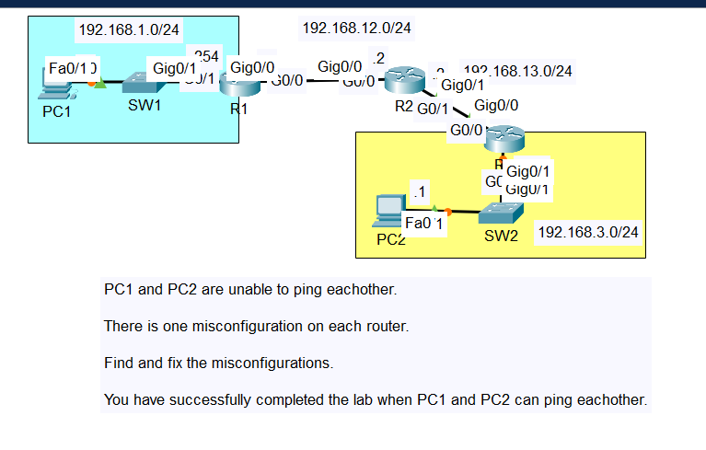

Objective

In this assignment you will troubleshoot a misconfigured Packet Tracer network configured with static routes.
You will need to find where misconfigurations take place and why the PC1 is not able to ping PC2.

Once you found the misconfigurations by making the appropriate corrections, answer the question below for each of the problems found. Run your tests again to confirm configuration fixes.

INSTRUCTIONS:

1. Start Packet Tracer, load the Packet Tracer provided with this LAB assignment.
2. Save your work right away in a file called Lab7-Troubleshooting your last names.

Please provide Answer to the following Questions:
3. What misconfigurations did you find?
Router 1:
The next hop address specified was 192.168.12.3, but it should have been 192.168.12.2, which is the IP address of Router 2’s g0/0 interface.
Router 2:
The static route to the network 192.168.3.0/24 is not properly configured to connect to the g0/0 interface as the exit point for the data
Router 3:
It isn’t properly configured to the interface g0/0
4. Where did you find these problems?
“show running-config | include ip route”
5. How did you fix these problems?
Router 1:
no ip route 192.168.3.0 255.255.255.0 192.168.12.3
ip route 192.168.3.0 255.255.255.0 192.168.12.2
Router 2:
no ip route 192.168.3.0 255.255.255.0 GigabitEthernet0/0
ip route 192.168.3.0 255.255.255.0 GigabitEthernet0/1
Router 3:
no ip route 192.168.3.0 255.255.255.0 GigabitEthernet0/0
ip route 192.168.3.0 255.255.255.0 GigabitEthernet0/1

6. Save Packet Tracer file using the name 420-421-_Lab7_-Solution.

7. Zip both Word document and your working packet Tracer file Save the completed file with your Student ID and Name (one student name and id is sufficient) and submit it as an attachment Lea.

- End of LAB 7 assignment -

